(Software Construction)
Task # 01

The Superior University
Faculty of Computer Science & Information
Technology
2023-2027

Submitted To:
Mr Hafiz Ali Ahmad
Submitted By:
Afzaal Mustafa
Roll No:
SU92-BSDSM-F23-037
Section:
6A

Department:
Software Engineering

Task#1
Create a Registration form in HTML :

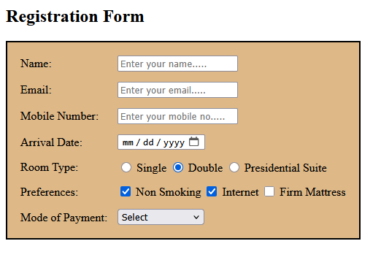

Task#2
You have to create the Coloured webpage in HTML.

